Occupational Health OPAS-G2 Online System
Guidance for BU Staff Members

Following review of your BU Staff Health and Wellbeing referral, onwards referral has been made to the university’s external occupational health provider Dorset Healthcare University NHS Foundation Trust utilising the secure online OPAS-G2 system.

The OPAS-G2 online referral system is fully managed by Dorset Healthcare University NHS Foundation Trust to provide a secure and efficient interaction between the university, staff member and Occupational Health. Referrals can be tracked and reviewed with real time communication throughout the process. The system is available on all platforms and is compatible with any browser.
Following submission of your referral via OPAS-G2, you will receive an automatically generated email with an individual code and link to access the OPAS-G2 system. Please see example email below which will be sent to the preferred email address provided in your referral from noreply@opasg2.com
This is a further opportunity for you to view the details of your referral and consent to this, prior to the external occupational health triage process. Please note that OPAS-G2 provides a limited timeframe of 48 hours in order for you to review and provide consent, before consent is automatically assumed.
If you have any queries or concerns, please contact Dorset Healthcare University NHS Foundation Trust Occupational Health Department directly via 01305 363800.
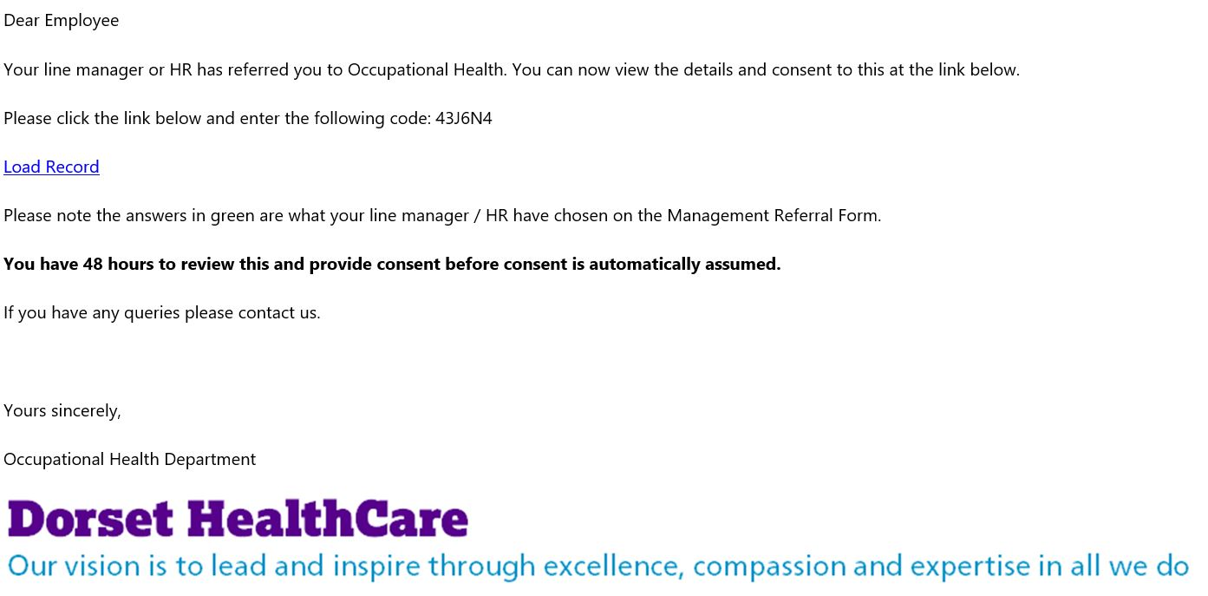
Occupational Health Triage
Occupational Health triage will commence following this 48-hour period, which will involve allocating your referral for OH Nurse or Physician consideration, along with scheduling an appropriate appointment duration and date. You will subsequently receive appointment notification.
Occupational health appointments are typically held remotely as video or telephone appointments and fully managed by Dorset Healthcare University NHS Foundation Trust. In some instances, a face-to-face appointment may be required, and these are held at Dorset Healthcare University NHS Foundation Trust clinics based at Holdenhurst Road in Bournemouth or the Forston Clinic in Dorchester.

Appointment Details
Your appointment details will be sent to you via the preferred email address stated in your referral. In some cases (for example, if a staff member is on sickness absence) Occupational Health may send these details via text message and/or by post. Your appointment notification will include a link to join the remote (video) consultation where applicable, along with the date/time and OH Practitioner name.
Please be advised that appointments are managed directly by Dorset Healthcare University NHS Foundation Trust. If you have any queries or concerns, please contact Dorset Healthcare University NHS Foundation Trust Occupational Health Department directly via 01305 363800.
If you are unable to attend the appointment, you must inform Dorset Healthcare University NHS Foundation Trust as soon as possible. In addition, please also notify the Health, Safety & Wellbeing team via staffhealthandwellbeing@bournemouth.ac.uk to assist in our case management.

Occupational Health Report
As part of the OH consultation you will be asked whether you wish for ‘Prior Access’ to view your OH report, before this is released to the university. Prior access is limited to two working days and provides an opportunity for you to challenge any factual errors which can be amended, however please be advised that the professional opinion expressed may remain unchanged.
You will receive email notification via OPAS-G2 when your report is available to download. Please see example email below which will be sent to your preferred email address from noreply@opasg2.com
Please be advised that following the two-working day ‘Prior Access’ period, the report is made accessible (‘released’) to the university in strictest confidence and remains accessible only to specified members of the Health, Safety & Wellbeing team.
Please note that you are advised to securely download a copy of your OH report as soon as this is available to you, as the OPAS-G2 link will not be available following release of the report to the university.
Following release of the report to the university, this will be reviewed by Karen Butters (Head of Health, Safety and Wellbeing) and Jo Coleclough (Health and Wellbeing Adviser). The report is not sent to your line manager. We will contact you to confirm that the occupational health report is available and advise you to share and discuss the content, including any recommendations, with the referring line manager. Many staff members choose to share the full OH report directly with their line manager at this stage, therefore it is helpful to securely download and save a copy of your OH report as soon as this is available to you for this purpose.

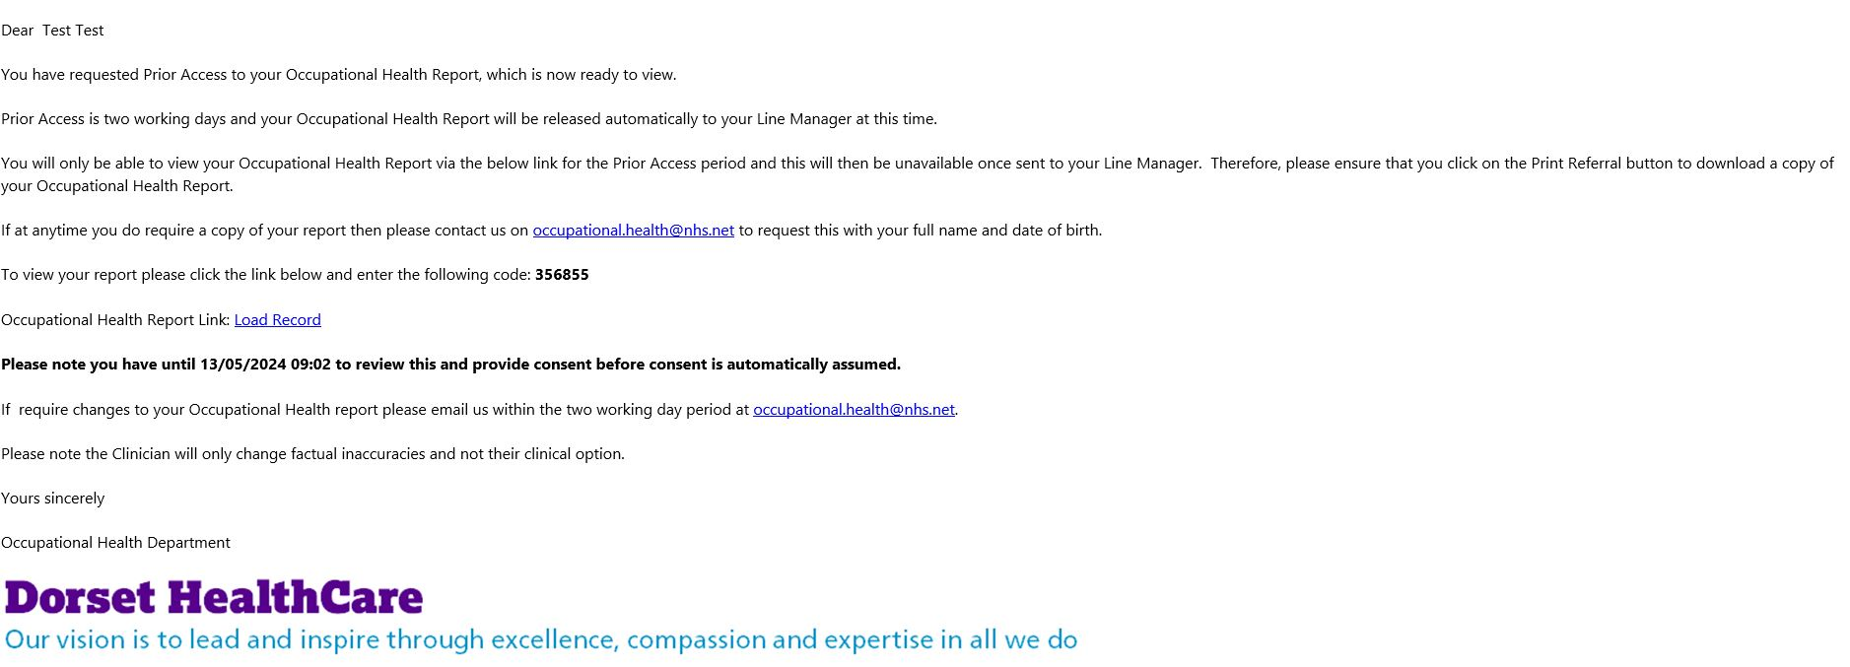

Feedback and Concerns
The OPAS-G2 online referral system is fully managed by Dorset Healthcare University NHS Foundation Trust. If you have any queries or concerns in relation to OPAS-G2 or the OH Consultation process, please contact Dorset Healthcare University NHS Foundation Trust Occupational Health Department directly via 01305 363800.
Any matters regarding BU staff health and wellbeing including occupational health, can be provided in confidence to staffhealthandwellbeing@bournemouth.ac.uk
This email address and the occupational health referral process is managed in strictest confidence by designated members of the Health, Safety and Wellbeing team. We aim to provide an excellent service that is responsive to the needs of the university and individual members of staff. All our processes are continually monitored for quality, suitability, and legal compliance. In order for us to deliver the service you want please let us have your feedback, including any concerns where appropriate, as often as possible.
If you feel dissatisfied in any way, please feel free to contact the Head of Health, Safety & Wellbeing directly on 01202 961131 or via kbutters@bournemouth.ac.uk
We will treat your concerns seriously, deal with them promptly and use your feedback to improve our service.

